Available Now From Cal Quake Inland Empire Located in

Highland, CA:
http://www.calquakeinlandempire.com/

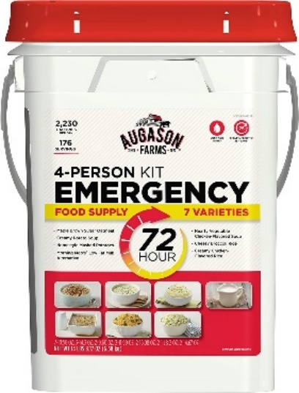

Augason Farms 5-20100 72-

4-Person Emergency Food Storage Kit 14 lbs 7 oz

176 Servings
26,440 Total calories
2,203 Calories Per Day
(16) Pouches with (7) Food Varieties
Up to a 20 Year Shelf Life!

Price: $84.95 No Tax.
If you order and pay a deposit of $5.00 with your order, your purchase will be
available for pick up at the Prepper Event on August 20 at The Ark
(These products are becoming hard to get. Don’t wait!)
The price on advance orders with a $5.00 deposit will be
discounted to $79.95 for the August 20 event.

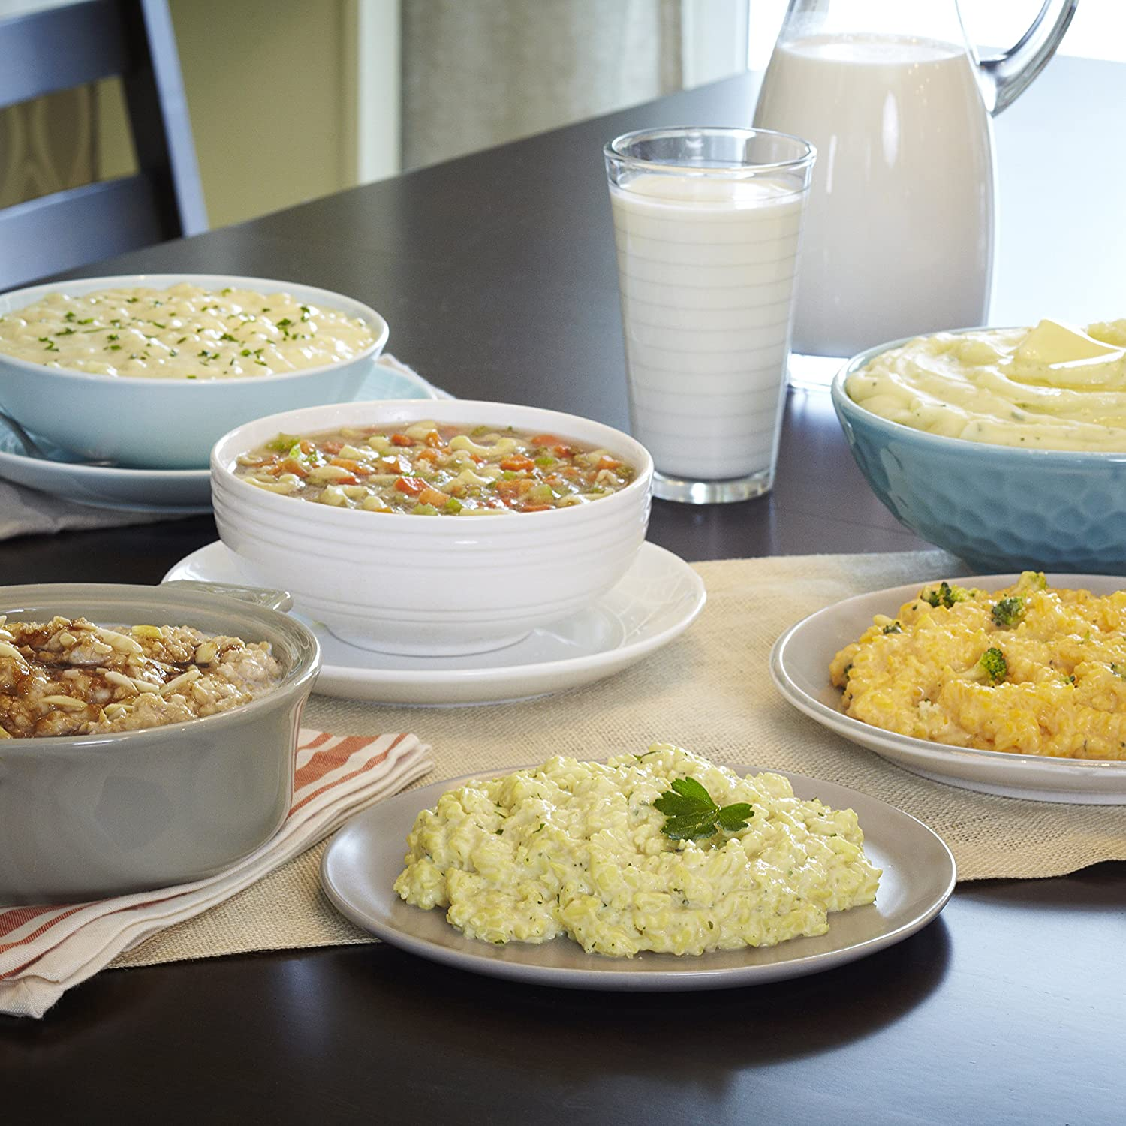

Available Now From Cal Quake Inland Empire Located in Highland, CA:
http://www.calquakeinlandempire.com/
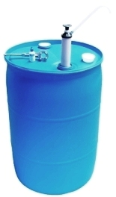

55 Gallon Water Barrels are a "Must Have" for Earthquake Preparedness!

These Water Storage Containers are not only Perfect for Family Earthquake Preparedness

and Survival Storage, but are ideal for Churches, Shelters, Offices, and Schools, as well.
55 Gallon Water Storage Barrel Only
BRAND NEW, Heavy-Duty BPA (Bisphenol-A) FREE and
FDA FOOD GRADE APPROVED.
You may pick up water barrels in Highland, CA 92346
Water Drum Only $59.95 $54.95 Limited Time Sale
Water barrels for pickup only. (Fits inside most full-size cars.)

* 55 Gallon Water Storage Barrel with ACCESSORIES
Water can be stored safely in these water drums to a minimum of 5 years
using our water preserver concentrate. There are 2 screw on bung caps
on top of each drum, which can be easily removed using one of our bung wrenches.
This is for placement of the screw-on siphon pumps. (Siphon pumps should not
be left attached to the bung openings as a means of capping the drums).
Please Note: The water storage drum accessories below are
discounted prices if purchased with the water barrel.
Special Offer: – All 4 accessories as shown with barrel purchase $89.95
You may online: http://www.calquakeinlandempire.com/storetitles/water/wtrsys.html

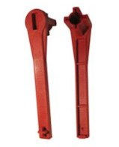  Heavy Duty Polyethylene  Bung Wrench - Gas Shut Off Tool  Used to cap and uncap your water barrel bung caps.  $7.95 | 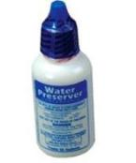  Water Preserver Concentrate  Just add to water when filling water drum.  Safely stores water for a period of 5 years minimum!  $12.95 | 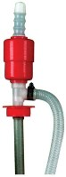  Siphon Pump w/ flow tube  Siphons 15, 30 and 55 gal. water containers with large flow hose.  Sturdy screw on  $13.95 | 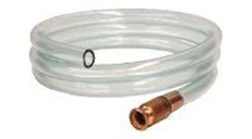  Self Prime Shake Siphon  Economical self priming siphon hose - can be used as main siphon source or for emergency backup.  $8.95

