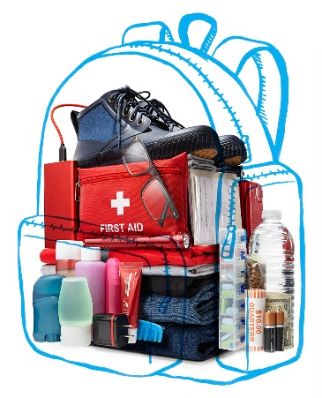
A ‘Go Bag’ Can Make All the Difference in an Emergency
Recent natural catastrophes, from hurricanes to western wildfires, are a fresh reminder that disaster can strike at any time. And no area of the country is immune, when you factor in the threat of tornadoes, earthquakes and human disasters like toxic spills. While the circumstances may differ, there’s one tip that every person needs to take from all these situations: how to pack a “go bag.”
A go bag is a packed case that you grab on your way out the door, and that will help keep you safe and comfortable in the coming hours and days. Stopping to hunt for your medications or other important needs can cost you critical seconds in an evacuation. Pack a separate go bag for yourself and every member of your household, and keep them stored in the same location.
I’ve interviewed hundreds of disaster victims, and compiled their recommendations below.
1. Basic electronics
Pack an extra phone charger in case you’re fortunate enough to have electricity, and a portable battery pack in case you’re not. Also stash a long-lasting LED flashlight. Pack a small hand-cranked or battery-operated AM/FM radio (with extra batteries).
2. Personal needs
While getting ready for a typical day, list every toiletry you use, then buy a travel-size version of each. Pack backup eyeglasses, as well as a first-aid kit, baby wipes and a multipurpose tool with a knife and can opener.
3. Clothing
Pack a few days’ worth. Include layers you can add or remove, plus lightweight rain gear and waterproof boots.
4. Your meds
Pack about three days’ worth of each of your prescriptions, which should last until you can get to a pharmacy that’s open. If you need larger items, such as an oxygen tank, make sure you have a portable version.
5. The perfect bag
Think small and portable. A backpack is ideal, but a lightweight suitcase with wheels will also do. Just remember, you may literally be running with it.
6. Paperwork
Fill a zip-top waterproof bag with photocopies of your birth certificate; driver’s license; Social Security and Medicare cards; power of attorney and will; any marriage, adoption or naturalization certificates; proof of address; insurance, medical and immunization records; and information about your credit and ATM cards.
7. Food and drink
Bottled water is essential. Granola or energy bars are great because they are small and filling, and they come in a variety of flavors.
8. Cash
In addition to enough money for a few days, include small bills and a roll of quarters. If you need to buy something out of a vending machine, you don’t want to start asking equally desperate strangers for change.
Jeff Rossen is NBC News’ national investigative correspondent and the author of the new survival and fraud-fighting book Rossen to the Rescue.

