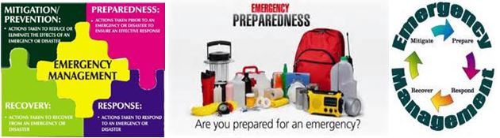

Master Camping First Aid Kit Recommended by Bob Colbert,

In Stock at Cal-Quake IE, http://www.calquakeinlandempire.com/
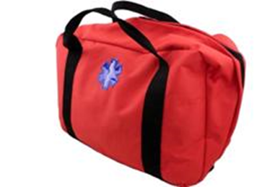
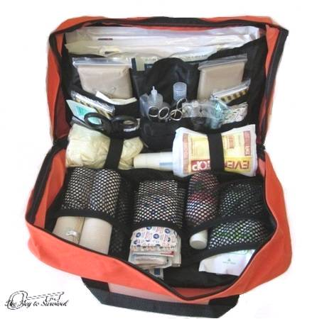
Master Camping First Aid Kit
Available in blue or red
Regular $99.95
$89.95

The Master Camping First Aid Kit is great for those looking for a better than usual first aid kit, containing a good assortment of supplies, yet still priced reasonably enough not to break the wallet. The Master Camping First Aid Kit bag folds out with a good overview of all the contents. First aid items are neatly arranged and organized in its many pockets, mesh pouches, and elastic divider straps. The FA126 Master Camping First Aid Kit has two carry handles for ease of use. Measures: 16''x 10''x 6'', and weights 8 lbs. Items in kit are listed below.

1- Carry Bag  1- pen light  1- suture package  1- first aid book  5- pair exam gloves  5 -abdominal pad 5" x 9"  30 -aspirin  6 -safety pins  1-emergency blanket 84" x 52"  1- hand sanitizer 2oz.  1- calamine lotion 6oz  1- hand soap  9- after bite wipes  1- Universal splint 4" x 36"  2 -6" elastic bandage  10- 4" x 4" sterile sponges  3- 1" tape  1- blood stopper kit  3- eye pads  2- Triangular bandages 40" x 40" x 56" | 32- 1" x 3" bandage strip  10 -butterfly strips  10- 2" x 3" bandage strip  10 -knuckle bandage  3- Ice pack  1- EMT shears  2- SS hemostats  1 -tweezers  2 -scalpel blades  3- tongue depressor  1- irrigation syringe  15- antiseptic wipes  15-iodine wipes  15- clean wipes  15- alcohol wipes  2- ammonia inhalants  2-multi trauma dressing 12" x 30"  1- sterile flushing solution  5- triple antibiotic  10- burn packages

