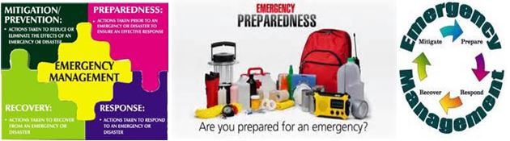
Time to Get Started “Prepping”!!!
Join our Kickoff Meeting, Thursday, August 20, 6:30-8:30p at The Ark
1307 E. Citrus Ave., Redlands, CA
Special Guest Speaker - Bob Colbert, Cal Quake Inland Empire
Learn the Essentials of Personal Protection and Survival and
What You Need to Prepare and Protect Your Family in an Emergency

- Water
  - Water storage, minimum two weeks, 55 gal barrel supplies family of 4 for 2 months.
  - Water filtration and purification system, in-home and portable
  - Bottled water, lightweight and portable
- Food
  - Portable Backpacks for autos and hiking, 3 day supply
  - Home storage for canned goods and dried foods, up to 1 year
  - Medications, two weeks ahead minimum
- Sanitation
  - Sanitation bags for auto travel
  - In-home potty and disposable sanitary bags
- First Aid
  - Bandages, tourniquets, antiseptics,

blankets, masks, gloves
  - Learn CPR, triage techniques and take CERT training
- Communication
  - Ham Radios or battery-operated radios
  - Networking and Telephone Chain
- Shelter, Stay or Flee
  - Flashlights, Candles, solar power generator
  - Map and shelter locations, travel routes for auto, bike and on foot
  - Network of shelter locations
  - Grab & Go Bag for cash in small bills, medications and legal papers
- Self-Defense – (last but not least)
  - Firearm training and permits
  - Pepper spray, warning whistle
  - Physical attack response maneuvers

When the emergency or disaster strikes it is too late to prepare or train.
More Info: Carolyn Hays, carhays@yahoo.com, Ph: 951-205-3690
Bob Colbert, Cal Quake IE http://www.calquakeinlandempire.com/
Resources and Training Team: Rachel Eugley, Ron Gravette, Claudia Millan, Sam Wong
Disaster Prep Products and Service Locations in the IE:
https://hub.biz/Redlands,CA/Earthquake-Products

Local Redlands Warehouse

Simpler Life Emergency

https://simplerlife.com/
EARTHQUAKE PRODUCTS AND SERVICES IN REDLANDS, CA
2035 W Park Ave Ste 1
Redlands, CA
(909) 798-8108
Large warehouse well-stocked. Example:
3 DAY EMERGENCY FOOD SUPPLY $74
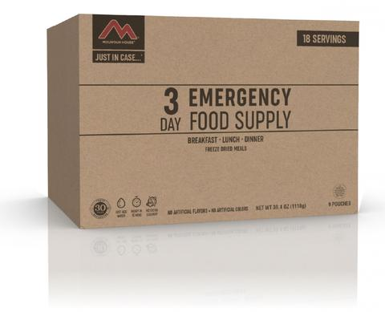

Online Resource Located in Highland, CA:
http://www.calquakeinlandempire.com/
Example:
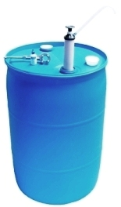
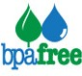 55 Gallon Water Storage Barrel Only
BRAND NEW, Heavy-Duty BPA (Bisphenol-A) FREE and
FDA FOOD GRADE APPROVED.
You may pick up water barrels in Highland, CA 92346
Water Drum Only $59.95 $54.95 Limited Time Sale
Water barrels for pickup only. Other purchases over $49, shipping is free

Famous Berkey Water Filtration Systems
Example: In-Home Counter Top Filters 6,000 gallons – Approx. $250
Available by Special Order Local Contact: Ron Gravette, Ph: 626/625-6293

