Self Defense Tools

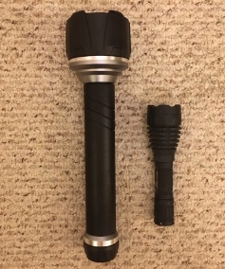  The large flashlight pictured on the left is 1,000 lumens, weighs 2 lbs. This would be good to use as a club to whack some-one over the head if you didn’t have any other weapons. And, it certainly will blind someone if you shine it directly into their eyes. However, this is not the best weapon for home defense. it’s too heavy to carry in one hand while your gun is in the other. The flashlight on the right is 600 lumens and is a good tool for home defense that you could keep on your nightstand. This would also be perfect for any bug out bag. Available most hardware stores. Pricing varies. | 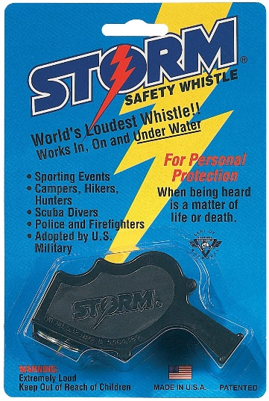  Storm World's Loudest Outdoor, Emergency, Safety, Marine, Police, Underwater, Survival Whistle | Proudly American Made.  The Storm® All-Weather Safety Whistle is the loudest whistle on the market. Its patented design allows the Storm whistle to be heard up to fifty feet underwater, due to its unique sounding chamber forcing out all water when the whistle is blown. $6.99 Amazon
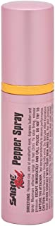  SABRE RED Lipstick Pepper Spray for Women – Pink, Maximum Police Strength OC Spray with UV Dye, Compact and Discreet, 10-Foot (3 m) Range, 12 Powerful Bursts – Cap Prevents Accidents. Compact lipstick design doesn't draw attention and fits discreetly in a purse, makeup bag or coat pocket; Cap design prevents accidental discharge for safe storage  $9.82 at Amazon | 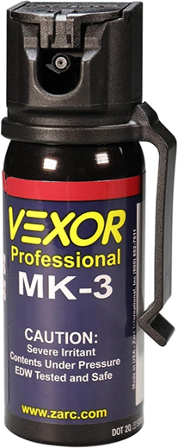  Vexor Pepper Spray with Belt Clip for Self Defense — Maximum Police Strength, 20-foot range, Full Axis (360°) capability, Flip Top safety for Quick and Accurate Aim, Protection for Women and Men. Best protection you can buy. Four- year shelf life. Should be kept out of reach of kids, either hidden or secured in the holster.  by Zarc $18 at Amazon

