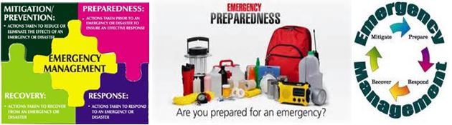

Four Sanitation Needs Recommended by Bob Colbert,

In Stock at Cal-Quake IE, http://www.calquakeinlandempire.com/

Emergency Toilet Seat Lid
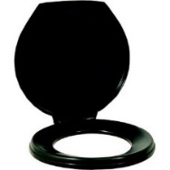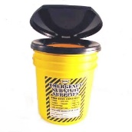
A folding portable toilet lid for a Honey Bucket Port-A-Pottie.
Can be used on your own 5 gal. bucket. Lid only. Ships in Black. $13.70
*****
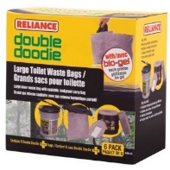
Reliance Double Doodie Disposable Toilet Bags
Features a Double Ziplock Seal. For a no mess, easy cleanup of all portable toilet waste there is nothing better than the Reliance Double Doodie Waste Bags. With a double zip locking mechanism that ensures a tight, leak-proof seal and a tough outer bag that minimizes any chance of puncturing, the Double Doodie is an essential for any portable toilet use. The Double Doodie with Bio-Gel is pre-charged with Bio-Gel waste gelatin powder that solidifies liquid waste and
masks odors.
Box of six - $18.70. If needed, one can be sold at $3.95 *****
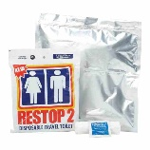

Restop 2 Disposable Travel Toilet
When Nature Calls - Be Prepared!
THINK ABOUT IT....
What if there was no other way?
Emergency Disposable Waste Bag
Especially recommended for your auto emergency kit

The Restop® 2 uses a patented "bag within a bag" design to safely contain and neutralize human waste. The outer bag is a Mylar gas-impervious bag. The Restop 2 system contains the odor as well as the waste, providing a user-friendly and pleasant means to pack out solid waste. Ample toilet paper and a moist antiseptic toilettes are included. Use with any commode system or can be used directly on the ground in wilderness situations.
$3.50 Each
*****
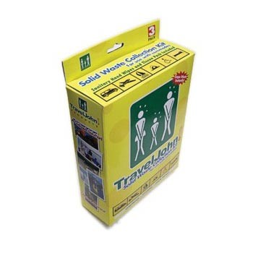
Travel John Solid Waste Kit
Absorbs, deodorizes, and disinfects instantly in the leak-proof LIQSORB® Pouch. Patented LIQSORB® absorbent pouch prevents leakage. Leakproof design. Disposable and bio-degradable plastic
Revolutionary "bag within a bag" design (Gusseted liner and zipper bag). Works like our personal disposable urinal with an extra wide spout for easy use. TravelJohn Solid Waste Collection Bags use the same revolutionary Leak-proof LIQSORB® Pouch and provide the same odorless, spill-proof protection.
Three Pack Kit - $9.95

Here's the breakdown:
The Go Anywhere Waste Kit and the Restop 2 Waste Kits can sell individually for $3.50 each.
The TravelJohn Waste Kit comes only in a 3 pack and can sell for $9.95 for those who would like a 3 pack kit
The Reliance Double Doodie Kit comes in a box of 6 for $18.70, if they would like to have a 6 pack. (providing it's back in stock at that time.) Again, I can sell them individually for $3.95 if needed.
I will keep checking on these and possibly call to see when they will be back in stock.
Again, they are going to want to know what the difference is between them, which one is better, etc. Except for the names, they are pretty much equal. You can try to get a feel of what they want and I will order accordingly (does not take long to get these).
.
Also - you might want to change the Toilet seat ad to read "Lid Only" instead of "Lid available" so they know it's only the lid they are getting.
I can get the 5 gallon pails also, but it would be at least another $11.00 more - not sure if they are willing to pay that, when they can get them cheaper elsewhere?

